Education as a life experience for self-esteem
Managing student recruitment in emerging African universities

Hicham Sebti, Assistant Professor, Euromed Business School, Euromed University of Fez, Morocco h.sebti@ebs.ueuromed.org

Introduction
Over the last two decades, there has been a growing acceptance of an open market approach to higher education, based on the assumption that students make rational choices of higher education institutions to meet their expectations. The higher education sector in African countries is facing a major challenge to support the social, economic and cultural progress of countries. According to the World Bank, only 7% of young Africans have access to higher education (compared to 76% in Europe) and less than 1% of the budgets of African states are invested in research and innovation. However, the sector has undergone significant changes over the last ten years with a trend towards massification and the rise of private universities. The expansion of these universities can be attributed to several factors, such as changes in government educational policy in a context of scarce public funding, unmet student demand in public universities, and private sector investment in higher education. These new private universities are trying to provide what the public sector has not been able to achieve.
Unlike public universities, private universities are well aware of the issues of competition to remain viable (Mustafa et al., 2018). Student enrollment is "the lifeblood of colleges and universities" (Kinzie et al., 2004: 4). Therefore, “the need to understand how prospective students decide which higher education institution to attend is becoming of paramount importance” (McManus et al., 2017: 2). Although the level of market orientation remains low among African higher education leaders - who have historically taken a passive approach to marketing and student recruitment because they were viewed with suspicion and seen as synonymous with a business perspective contrary to the values of the academic community - in recent years, there has been a growing awareness of the need for a marketing and development strategy. Given the significant challenges facing new private universities, they need to develop a marketing culture to deliver consistent communication messages and reach their target students. Gradually, marketing and development strategies are becoming a central issue and a critical function for the survival of a university.
From a consumer behavioural perspective (Craig-Lees et al., 1995), the choice of higher education institution is a complex decision (Angulo et al., 2010). So far, this choice process has been little explored in the Arab and African contexts (Mustafa et al., 2018). This paper attempts to address this issue. Our contribution aims to provide a better understanding of student recruitment by addressing the issues of the student choice process. The knowledge and insights that emerge from this study will enable marketers in African institutions to better understand what is likely to influence the behaviour of their prospective students.
The article is structured in four parts. The first part presents the theoretical framework, focusing on marketing and the choice process in higher education. The second part focuses on the methodological approach. The third part presents our main findings. We have concluded by highlighting three sources of mismatch between students and institutions that reflect the inconsistency between university communication and student expectations.

Marketing in Higher Education and the student choice-making process

1. Marketing strategy in Higher Education
Strategic marketing of higher education encompasses the efforts of higher education institutions to better understand the needs of their potential customers in order to design products and services that meet and exceed those needs (Mogaji et al., 2020). According to Levitt's (1980) description of marketing strategies, university offerings can be categorized into three levels. First, the core offer: students buy the benefits that a degree can bring them in terms of employment, status and lifestyle. Second, the tangible attributes of the offer: these include the physical layout of the campus, the library, laboratories and sports facilities. Finally, the augmented product: this consists of intangible attributes such as student loans, employment or placement services. The marketing strategy articulates the interaction between stakeholders (customers, company and employees) and value-based activities (value exploration, value creation and value delivery), which creates, maintains and renews customer value (Pinar et al., 2011; Kotler and Keller, 2015). In the context of higher education, marketing strategy includes decisions about programs, targeted students, market opportunities and competition. Thus, a successful marketing strategy in higher education pays great attention to understanding students' needs and expectations (Maringe, 2005) while respecting the specific geographical, economic, political, sociological, technological and ecological context.

2. Higher education choice-making process
The choice of a higher education institution is a complex behavioural process based on psychological, social and contextual factors (Brennan and Marriott, 1996; Cabrera et al., 2000).
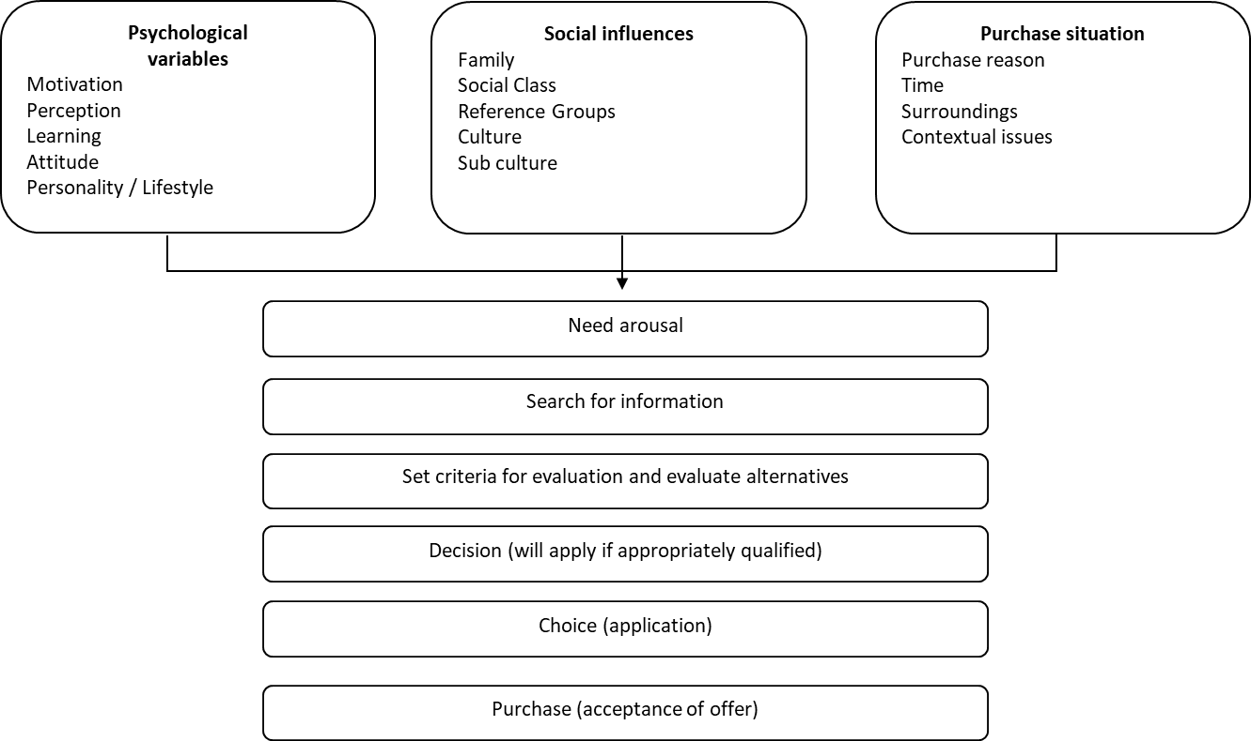
Figure 1: Conceptual model of the customer behavior process (adapted from Brennan and Marriott, 1996)
Several empirical works have addressed the student choice process, describing it as a key and highly involving decision in the life of each individual (Angulo et al., 2010), and as "a complex process that involves different perspectives and a myriad of factors" (Mustafa et al., 2018: 2). Studies identify factors such as curriculum and course availability; location/distance from home; relevance of the course to the chosen career path; reputation of the institution; placement and career guidance; costs associated with attendance ; admission criteria; prestige and status of the institution; educational facilities; campus size and type; opportunities for extracurricular activities; campus facilities; student welfare programs; teaching and research staff; qualifications and experience; etc. The weighting of each criterion depends on the student's decision-making ability and the level and type of information-seeking activity undertaken by the prospective student.
The literature on marketing in higher education identifies two dominant models of student choice. First, the economic model, which states that students choose a university based on their perceived costs and benefits. Second, the sociological model, which emphasizes social and cultural issues as the main factors of choice. In their review of the empirical literature on higher education institution choice, Mustafa et al (2018) report on social factors of choice that fall into three main types of influence. First, student characteristics such as socio-economic variables, academic ability, occupations and parental income. Second, institutional variables that include the image and academic reputation of the institution, especially the quality of courses and teaching as well as the quality of facilities. Finally, the cultural background and other significant influences that affect student decisions. Thus, the final choice is influenced by a complex combination of social pressure, personal expectations, motivation, and aspiration, all of which are linked to both rational and emotional perspectives on decision-making (Angulo et al., 2010).

3. student-institution fit
Student-institution fit (Bowman and Denson, 2014) refers to the psychological state the student is in when receiving information about the university and its programs. Empirical work in social psychology shows that the importance placed on the decision and the degree of involvement of the actor increase sensitivity to the message (George and Manoj, 2009). As the choice of a higher education institution is a complex and cognitively demanding decision, involving issues of self-esteem and social recognition, it is highly exposed to psychological variables and effects. As consumers, students are highly involved cognitively and emotionally when seeking information (Schmidt and Spreng, 1996) due, first of all, to the importance and implication of the decision on their lives.
Empirical research distinguishes two phases of consistency analysis (Krishna, 2012) that allow each individual to define the congruence of the message with his or her own cognition. First, a phase of conscious and objective sensory experience, through which the individual receives the message (informational or sensory). Second, a subjective phase of awareness, understanding, evaluation and categorization of this message. As a result of these two phases, the student's psychological state will be positive or negative depending on the consistency of the university's message with the student's knowledge, opinions, values and feelings.

Research methodology
We used a qualitative approach to investigate student decision making and the emergence of cognitive inconsistency during this process. The qualitative approach is particularly relevant when attempting to contextualize studies and capture the complexity of a process such as decision-making. We conducted case studies on the summer 2018 recruitment campaign of some newly launched academic programs (in social sciences and business studies) in a young Moroccan private university in Fez, the Euromed University of Fez (UEMF).
Background
UEMF, created in 2015, is organized in six specialized schools: Architecture, Political Sciences, Business, Social Sciences, Engineering and Applied Sciences. UEMF defines its offer around seven "pillars": the desire to promote multilingualism, multiculturalism, entrepreneurship, eco-citizenship, international mobility, multimedia & information technologies and social responsibility. The university also develops a positive action towards young people from underprivileged families by granting them scholarships, thus enabling them to advance professionally in their lives. In our study, we focus on social science programmes at the Bachelor or Master's level in political science, business communication and tourism.
Data collection
For each program, we collected data on the curriculum, pedagogical specialties, and marketing and communication strategies that characterize the offering, including data from informal interviews with curriculum developers. We also collected data on student and prospect discourse in order to capture their cognitive representations and assessment of the offering. To this end, we conducted focus group interviews with students. These aimed to capture the common patterns of individual experiences in the choice-making process in order to understand the range of conscious and subconscious means of selecting higher education institutions used by students. We also collected written data from mail and social media interactions between curriculum developers and potential students.
Data Analysis
The data collected was analyzed by content analysis using the method recommended by Miles and Huberman (1991). Using this method, "meaningful subsets" were derived from the collected data using a multi-theme inductive coding approach to generate key themes related to the research objectives described above.

Students decision making criteria: expecting a life experience and self-esteem
Our contribution aims to provide a better understanding of student recruitment by addressing issues in the student choice-making process.
We identify some of the critical decision criteria used by students to evaluate the perceived value of the university academic offer. We distinguish two sets of choice criteria. On the one hand, "self-centric criteria" which include socio-economic and cultural choice factors. On the other hand, the "university-centric criteria" which refer to the institutional factors that make up the value of a university offer.

1. Self-centric criteria: study choice as a management of self-esteem
The choice of a course of study and an academic itinerary appears to be a binding decision, a key stage in the lives of the young men and women. The importance attached to this decision-making process is a source of great anxiety and stress, both for students and for their friends and family.

1.1 The personal desirability factor
The first concern expressed by the students is the wish that their personal learning experience can correspond faithfully to their personal aspiration and the image they build of themselves, and that it can contribute to strengthening their self-esteem. This corresponds to a kind of personal desirability. This dimension of self-esteem is even more important for students who perform well, allowing them to genuinely choose their academic itinerary.

1.2 The social desirability factor
The second dimension related to self-esteem criteria relates to the need to choose a ‘socially desirable option’. This social desirability gravitates around the questions concerning the reputation of the chosen university as well as of the jobs the academic itinerary would lead to. The issue concerning the reputation is described in numerous articles on marketing in higher education. Prospective students are particularly concerned by university reputation inside their social environment. Studies need to look serious. Another side of social desirability refers to the prestigious jobs that the academic itinerary leads to. The representations and ethos around what makes a job prestigious change from one social background to another. However, more often than not, students tend to agree on the fact that jobs derived from scientific training (engineers, doctors, pharmacists, architects, etc.) are much better regarded by society than jobs related to social sciences.
The second dimension related to self-esteem criteria concerns the need to choose a "socially desirable option". This social desirability revolves around questions concerning the reputation of the chosen university and the jobs to which the academic itinerary would lead. The issue of reputation is described in many articles on marketing in higher education. Prospective students are particularly concerned about the reputation of the university in their social environment. Studies must look serious. Another aspect of social desirability concerns the prestigious jobs to which the academic itinerary leads. Representations and ethics around what makes a job prestigious change from one social environment to another. However, more often than not, students tend to agree that scientifically trained jobs (engineers, doctors, pharmacists, architects, etc.) are much better regarded by society than jobs related to the social sciences.
Social desirability emphasizes the important role that 'the significant others' (Mead, 1934) play in decision making. Even when students make their own decisions, they are still heavily dependent on the social pressure around them when choosing their field of study and work. Student choice making criteria are therefore filtered by motivational factors related to the student's cultural background and social environment.

2. University centric criteria: study choice as a search for a life experience
According to Levitt's description (1980), the university offerings can be classified into three categories: the core offer, tangible attributes, and augmented product.

2.1 The core offer: Getting a diploma and a status
In the context of Moroccan-North African culture, whether or not the state recognises a specific qualification remains of crucial importance. The importance given to the ‘national diploma’ is considerably reinforced by the attraction that most people have for civil servant positions. The career path in the ‘Fonction Publique’ is automatically associated to security and stability in an economic context where unemployment is high and perceived as a high social risk. This phenomenon is further accentuated in lower-class students, whose economic and social capital is fragile and who consider their qualification as their unique and valuable capital.

2.2 The tangible attributes: Workability and Instagrammability
In addition to the importance attached to the qualification, students also take into account certain tangible attributes such as the quality of the university campus, its modernity, the university residence, the campus cafeteria, in other words the entire university facilities.
Potential students evaluate the campus and university facilities both from the rational point of view of working conditions and from the emotional point of view. They want comfortable conditions for studying and working. This is what we call campus workability. Students also want a place they can identify with and be proud of. This is what we call campus instagrammability.

2.3 The augmented product: a promise of internationalization
The opportunity to study abroad and to benefit from international academic exchanges seems to be particularly appreciated by students. It is perceived as an ‘opening opportunity’, the chance to develop new skills, but also as a stepping stone to pursue studies abroad and eventually settle in.
In addition, the internationalization of the faculty, with French, Italian and Spanish professors (to name but a few nationalities) participating in the realization of the teaching modules, is important. This is preceived as a sign of prestige and quality. The presence of foreign professors is therefore described as a sign of the university's international standing, from which students derive a form of prestige for themselves.

Student-higher education institution misfit
In this first analytical part, we have identified some issues that shape future students' representations of their interests, needs, preferences, and expectations. Those related to acquiring status and belonging to a group appear to be of paramount importance. We also point out that students weigh rational and emotional sources of value in the university offering. The mismatch between these representations and the marketing messages of universities can lead to inconsistencies. In what follows, we present three sources of mismatch between students and higher education institutions.

1. The forward-looking perspective misfit
One of the main inconsistencies described by students concerns the gap between the academic offer and students' perceptions of the labour market. In particular, university courses that lead to jobs that are not yet well known (such as political sciences) or that are not socially valued and considered a source of prestige generate a certain psychological discomfort among students and among their families and friends. Other courses that are considered innovative (such as sustainable development and the circular economy) cause similar psychological discomfort and are an important reason for not enrolling in a course. The anxiety of being qualified but unemployed is rather high.
Prospective students find refuge in jobs they know well. This is therefore a major challenge.

2. The teaching methodology misfit
The second source of misfit concerns the content of the curricula and the teaching methods offered by the universities. This type of dissonance seems to reveal a profound mismatch between, on the one hand, the university's willingness to innovate pedagogically and, on the other hand, a certain form of conformism in the expectations of students and parents and in the representation of the learning process.
This discrepancy is further reinforced when the university emphasizes a new philosophy of learning and asks students to develop a new approach to work. This is the case with entrepreneurial orientations or critical thinking. Myths and stereotypes about visionary and risk-taking entrepreneurs can be intimidating for young people who tend to have a somewhat less heroic view of themselves. More generally, prospective students who lack cultural and economic capital do not see soft skills as an opportunity for personal development but rather as a detrimental element to their educational pathway.

3. The educational goal and ROI misfit
The last form of informational inconsistency concerns the attitude of prospective students towards the academic goal. Prospective students are much more concerned with acquiring a qualification than with acquiring knowledge and skills. This representation gap is very clearly evident in a number of cases. Students appear to attach less importance to course content than to forms of qualification recognition. Some prospective students see their higher education choice as an expense that should enable them to obtain a short-term return on investment through professional opportunities rather than as a means of personal development. Thus, any message focusing on knowledge and skills that are not directly related to a job or promotion opportunity is seen as inconsistent.
This preference for qualification rather than for the development of knowledge and skills becomes even clearer when talking about continuing vocational training courses.
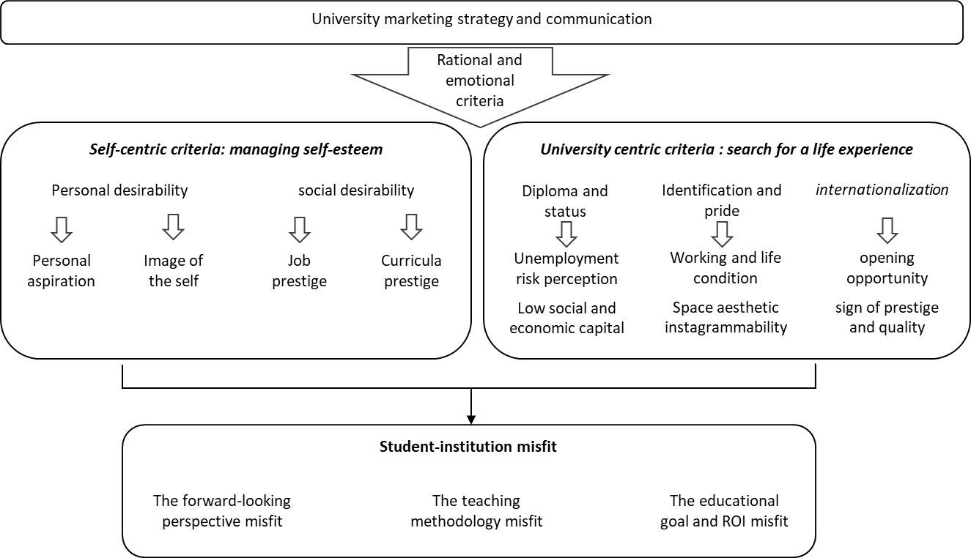
Figure 2: the advent of student-higher education institution misfit

Managing student-institution misfit
In this contribution, we have attempted to provide a better understanding of student recruitment in the context of a young North African university. We have explored the rational and emotional issues that influence the choice of students for a higher education institution. We distinguished, on the one hand, student-centric criteria that refer to social and self-esteem motivations, and on the other hand, university-centric issues that refer to the components of the university offer that are valued by prospective students. Then, we identified three sources of mismatch between the university's marketing strategy and the representations and expectations of prospective students.
Based on these findings, we make a series of strategic and operational marketing recommendations that could help reduce the mismatch. Universities should work from two perspectives that may seem paradoxical, but are rather well connected and complementary. On the one hand, universities should increase the universality of their strategic discourse to society and prospective students. In this perspective, universities should disconnect their strategic vision from local and temporary constraints to be forward-looking and globally oriented. In other words, universities should not be preparing for today's and local jobs, but rather for future and global careers. On the other hand, operational actions should be more specifically oriented to meet the expectations of future local students and their ability to understand messages and innovative methods.
We have described above a set of motivational criteria and influences at stake in the choice of prospective students. Those related to acquiring status and belonging to a group are of paramount importance in a North African context. We also point out that students weigh rational and emotional sources of value in the academic university offering.

1. A global and future oriented strategic vision
Higher education strategies should aim to promote a "raison d'être" for the university (Kotler and Keller, 2015: 753) through its strategic vision. The university must build and communicate a vision around what we might call the "jobs of the future" - some of which may not even be known yet - as well as around the new skills needed, such as teamwork, negotiation, resilience and adaptability, open-mindedness, critical thinking, etc. Clearly, this can sometimes be confusing for students who are mainly interested in what profession the degree prepares them for, or who are uncomfortable with the new learning methods.
From this perspective, the content of the university's communication materials should not focus solely on describing the programs. Rather, it should promote a vision of the future and how the university intends to contribute to its realization through carefully designed courses. To reinforce and legitimize this vision, universities and program managers should work more closely with socio-professionals in the design and implementation of courses. This collaboration would help identify the knowledge and skills needed for the coming years and help students to better understand what is coming.
Furthermore, MENA and African universities in general should invest more time and energy to increase their integration into the global higher education system in order to enhance the universality of their positioning (Benabdallah, 2010). Students and academics from the South should be helped to gradually perceive themselves as part of a global - or at least regional - community of learners and knowledge producers. The establishment of strong and strategic partnerships between universities - facilitating the mobility of students and researchers and progressively aligning teaching and learning approaches - is a powerful tool to achieve this goal. However, networks of interpersonal links and collaboration between scholars or student associations should also be fostered.
We strongly believe that efforts towards a comprehensive and forward-looking strategic vision for the university and the promotion of universal goals could help to reduce the geographical, temporal and cultural sources of cognitive inconsistency that we have identified in our contribution. Prospective students should gradually become comfortable and increase their capacity to adopt the representation promoted by the university regarding a universal projection into the future.

2. Operational actions to tackle local contingencies and sources of inconsistency
In parallel with the promotion of a strategic vision, African universities need to act at the operational level to eliminate sources of inconsistency and psychological discomfort in their communication messages. To do so, universities should, first, develop tools to better know the potential students they target and, second, choose a persuasive communication approach to reach them.
One of the major difficulties of African universities is the lack of knowledge of the social background and the expectations of their potential students. This lack of knowledge leads them to develop messages that meaningless to young people. Thus, like companies, universities need to improve their understanding of the expectations and motivational levers of students and prospective students. They must rely on marketing studies that allow them to segment student populations and identify the traits, motivations and fears of each individual. This knowledge will make it possible to adapt the content of communication messages to different student profiles in order to reduce informational inconsistency for each student segment. To amplify the impact of this message, universities should use the right communication channels that specifically target their prospective students. In particular, universities should rely on digital marketing to collect and analyse data and use social media platforms and influencing social media to target specific groups of prospective students.
Similarly, universities need to rely more on alumni and current students to disseminate their communication messages. Alumni are significant people with whom prospective students can identify. When the university's message is explained by the students themselves, it appears less inconsistent, on the one hand, because of the linguistic proximity between young people using the same words, and on the other hand, because students describe a truly lived and shared consumer experience. More generally, students and prospects share generational codes that reduce the risk of misunderstanding or inconsistency in the message received, as is very often the case with professors and program managers.

Given the significant challenges and strong competition in the private higher education sector, there is now a willingness on the part of universities to adopt a marketing approach (Ivy, 2001, Mount and Belanger, 2004). By incorporating marketing into the culture of the school, higher education institutions are looking for smart ways to adapt to their competitive environment and to overcome the challenges they may face.
References
Angulo, F., Pergelova, A., & Rialp, J. (2010). A market segmentation approach for higher education based on rational and emotional factors. Journal of Marketing for Higher Education, 20, (1), 1-17
Benabdallah, M.Z (2010). L'université maghrébine face aux défis de l'intégration euro-
Méditerranéenne. La Cuestion universitaria 6, 2010, 117-124
Bowman, N. A., & Denson, N. (2014). A missing piece of the departure puzzle: Student–institution fit and intent to persist. Research in Higher Education, 55, (2), 123-142.
Cabrera, A. F., & La Nasa, S. M. (2000). Understanding the college‐choice process. New directions for institutional research, 2000, (107), 5-22.
Cappeleare, G. (2019). MENA’s growing young population is a huge opportunity – if we get it right. World Economic forum. https://www.weforum.org/agenda/2019/04/menas-growing-youngpopulation-is-a-huge-opportunity-if-we-get-it-right/
Craig-Lees, M., S. Joy, & al. (1995). Consumer Behaviour, Milton, Queensland, John Wiley & Sons.
George B.P. et Manoj E. (2009). Cognitive Dissonance and purchase involvement in the consumer behavior context, The IUP Journal of Marketing Management, 8, (3), 7-24.
Hemsley-Brown, J., & Oplatka, I. (2006). Universities in a competitive global marketplace: A systematic review of the literature on higher education marketing. International Journal of public sector management, 19, (4), 316-338.
Ivy, J. (2001). Higher education institution image: a correspondence analysis approach, International Journal of Educational Management, 15, (6), 276-282.
Kinzie, J., Palmer, M., Hayek, J., Hossler, D., Jacob, S. A., & Cummings, H. (2004). Fifty Years of College Choice: Social, Political and Institutional Influences on the Decision-Making Process. New Agenda Series. 5, (3). Lumina Foundation for Education.
Kotler, P., Keller, K.L. (2015). Marketing Management. 15th Ed. Tours, Nouveaux Horizons.
Krishna A. (2012). An integrative review of sensory marking: engaging the senses to affect perception, judgment and behavior, Journal of Consumer Psychology, 22, (3), 332-351
Levitt, T. (1980). Marketing success through differentiation-of anything. Boston : Graduate School of Business Administration, Harvard University.
Maringe, F. (2005). Interrogating the crisis in higher education marketing: the CORD model. International Journal of Educational Management, 19, (7), 564-578
McManus, R., Haddock-Fraser, J., & Rands, P. (2017). A methodology to understand student choice of higher education institutions: the case of the United Kingdom. Journal of Higher Education Policy and
Management, 39, (4), 390-405
Mead, G.H. (1934), Mind, Self and Society, University of Chicago Press, Chocago.
Miles, M., & Huberman, A.M. (2003). Analyse des donnees qualitatives. Bruxelles: De Boeck Universite Mogaji, E., Maringe, F. & Hinson, R.E., 2020. Higher education strategic marketing and brand communications in Africa. In: E. Mogaji, F. Maringe & R. E. Hinson, eds. Strategic Marketing of Higher Education in Africa. Abingdon Oxfordshire: Routledge.
Mount, J, & Belanger, C. (2004). Entrepreneurship and image management in higher education: pillars of massification, The Canadian Journal of Higher Education, 34, (2), 125-140.
Mustafa, S. A. A., Sellami, A. L., Elmaghraby, E. A. A., & Al-Qassass, H. B. (2018). Determinants of college and university choice for high-school students in Qatar, International Journal of Higher Education, 7,
(3), 3-15.
Pinar, M., Trapp, P., Girard, T., & Boyt, T. E. (2011). Utilizing the brand ecosystem framework in designing branding strategies for higher education. International Journal of Educational Management, 25, (7), 724-739.
Schmidt, J. B. and R. A. Spreng (1996). A proposed model of external consumer information search.
Journal of the Academy of Marketing Science 24, (3), 246-256.

